Macintosh HD:Users:christinajames:Library:Containers:com.apple.mail:Data:Library:Mail Downloads:0574015E-144D-42FF-B175-7D2FFE734D34:PastedGraphic-19.pdf

***He said to his disciples, “The harvest is great, but the workers are few. So pray to the Lord who is in charge of the harvest; ask him to send more workers into his fields.” Matthew 9, 37-38***

Tal James

**Tal and Christina James May 2016**

***News Update***

***Dear Friends,***

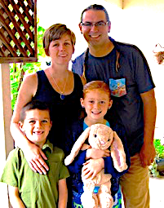Since the beginning of the year our team has grown: Joe and Meredith Lopez and their children Lucy (9) and Brennan (7) have joined the R.O.O.T.S. team and will work with us focussing mostly on Penelakut. I am pretty sure we introduced them before, but here is a quick reminder. Joe is Apache and grew up in downtown Los Angeles. Meredith is from Alaska and spent a large part of her childhood on a tiny First Nations Reserve/Island being the only white kid “in town”. The family arrived on New Years Eve from Los Angeles and has since tried to adjust to all the rain, the cold and the Canadian politeness ☺.

We are very excited to have them finally with us; they are an awesome and very valuable addition to the ministry.

Meredith and I (Christina) will work together on the ROOTS House process, aside from volunteering and being involved in the Penelakut community, on top of that Meredith is working on her counselling degree. Joe is joining Tal and Tim in offering community activities as a tool to speak into people’s life. Additionally Joe used to have a construction business in Los Angeles and will be involved in any way needed in the building of the ROOTS House. They really want to see this happen, as they are also convinced of the value and need of such a building on Penelakut. At the moment they are in the “introduction” phase. We appreciate your prayers for them.

Micha, our Volunteer from Germany left middle of April. Here some more of his impressions:

*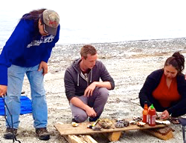Working on Penelakut I had to get used to many differences to Germany, that were influencing my daily life. The most challenging difference was that you have to be spontaneous at all times, and never knew what to expect. Many plans to meet with friends or go to events are arranged or cancelled at a very short notice. With time I got used to that and got more flexible in my planning as well. I started to only make a rough plan for the day, in the hope (but not expectations) that it will happen.*

*Oysters on the beach*

*When we were on Penelakut we often helped elders with small and sometimes bigger chores. In Germany people usually ask directly for help, but on the reservation I had to learn to offer my help or even simply do it, without asking. First Nations hardly ever ask for help directly, a wish for help is often only hinted at. And even when offered help is denied, the “No” does not always mean “No”. That was not easy for someone from a culture, that is pretty direct. Another difference was that a lot of things are suggested or said, without them happening in the end. For example when you are invited to go fishing or to meet, then it does not mean that you are planning for a date to do it, but only that it is a general invitations, to do it sometime (maybe). Only after an invitation has been repeated several times, you can be sure that it was meant seriously and wasn’t only a polite gesture.*

In the middle of January Tal had a bit of a too close encounter with his truck. While lying under it for repairs it started rolling down our driveway and he just managed to move his head away from being rolled over by his 1-ton. Instead it “only” rolled over his foot. Miraculously, nothing got broken (good hiking boots, I guess), though Tal’s foot has been hurting ever since. We are very thankful for God’s protection, this could have had a much worse ending.

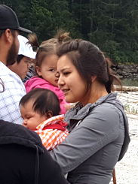

Finally an urgent prayer request: Many of you probably remember Tal’s cousin, that was shot by her husband over 10 years ago. Her then 6 year old daughter D. had been the only eyewitness. She is now 17 and is fighting with many symptoms resulting from that traumatic experience, among others substance abuse. Right from the beginning she has refused any counselling and has never spoken about the event except in the very first police interview. In the last 2 years her behaviour has become more and more extreme. We have now initiated something like an intervention together with the most affected family members. D. had agreed to go the a treatment center, but refused to stay at the very last minute. We are now looking into finding a different form of treatment for her, together with the family she has been staying with for the last 5 years (her cousin). The situation is very complicated and I can’t go into detail in this letter, but please pray for D. and for her family, for God’s wisdom and open doors.

*Our niece Taylor*

***Huy'ch q’u Siem (Thanks to all of you! / I raise my hands to you!)***

***Tal and Christina with Corbin and Connor***



**USA:**

Box 499  
Sumas WA 98295

**CANADA:** Box 220, Station A Abbotsford BC V2T6Z6

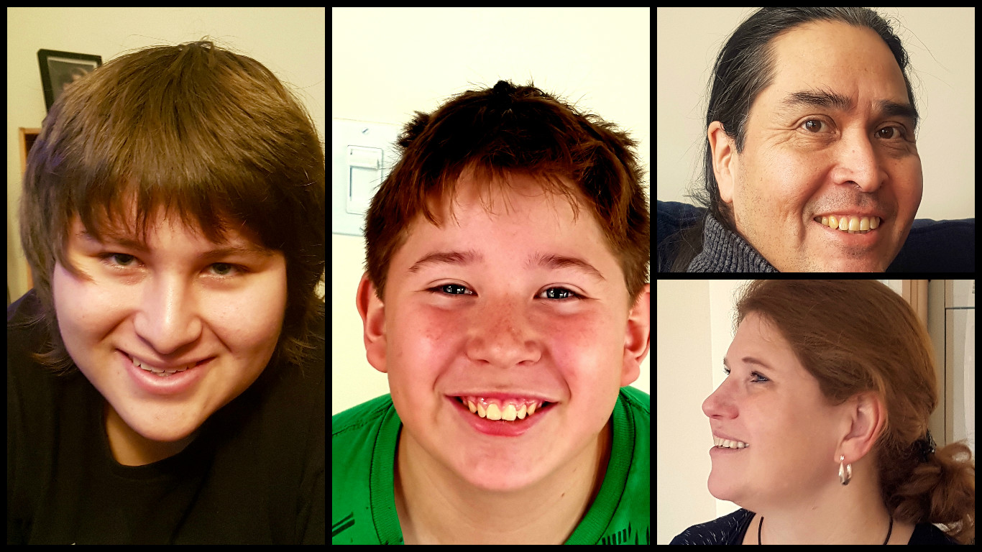

**Tal and Christina James**

**395 Harwell Road, Nanaimo, BC, V9R 6Y8, Canada Telephone (250) 753 6504 Email** [**james@naim.ca**](mailto:james@naim.ca)

**Website** [**http://roots4naim.weebly.com/**](http://roots4naim.weebly.com/)

**Password: TEAM**

Please make out **donations** to **NAIM**, **Project Number 620** and check out your options at [www.naim.ca](http://www.naim.ca)

**NAIM staff and the ministries they represent are solely funded through and fully accountable to North America Indigenous Ministries**

